**DATA MANAGEMENT AND DATABASE DESIGN**

**PROJECT**

**Team Name: Resonance**

Shubham Prakash Chaudhari

Madhav Gopinath Sirsat

**Introduction:**

* Background

As per the current COVID-19 pandemic scenario, hospitals and governments are having hard time keeping track of the recovered and active COVID patients and plasma donors. In instances, it also has been observed that the plasma is issued to low-risk patients who do not have immediate necessity instead of high-risk patients. The existing system is based on assessment of biographical information and medical history of the donors and patients which is inefficient and does not incorporate key data like results of COVID tests, real-time health status of donors, current patients admitted and donors nearby hospitals, the demographical and geographical data of the hospitals etc. Considering this, there is a necessity of implementation of database management system in the aforementioned data system.

* Goal

The objective of this master’s project is to create a database to centrally handle the information of all the Hospitals, Patients, Doctors and Plasma Banks in a region, and to provide access to this information with an easy to use web-based interface that can be accessed by any device with basic html rendering capabilities.

**Attributes:**

1. User_Credentials
2. Hospital
3. Doctor
4. Patient
5. Plasma Bank
6. PB_inventory
7. Hospital_Request
8. Hospital_Withdrawl
9. Doctor_Request
10. Doctor_Withdrawal

**Data Dictionary**

1. **User_Credentials**

|  |  |  |  |
| --- | --- | --- | --- |
| **Column** | **Data Type** | **Description** | **Example** |
| User_ID(PK) | INT(5) | Unique Key to Identify each user. | 11109 |
| Username | VARCHAR(10) | Usernames generated by end users | mssirsat |
| PIN | INT(6) | Six-digit PIN generated by user to login | 300696 |

1. **Hospital**

|  |  |  |  |
| --- | --- | --- | --- |
| **Column** | **Data Type** | **Description** | **Example** |
| H_ID(PK) | INT(4) | Unique ID associated with hospitals, Starts with 1 | 1109 |
| User_ID(FK) | INT(5) | Unique Key to Identify each hospital. | 11109 |
| H_Name | VARCHAR(40) | Name of the Hospital | Boston Medical Centre |
| H_Address | VARCHAR(100) | Address of the Hospital | 111 Huntington Avenue, Boylston St, Boston, MA 02199 |
| H_Phone | INT(10) | Phone number of the hospital | 6176388000 |

1. **Doctor**

|  |  |  |  |
| --- | --- | --- | --- |
| **Column** | **Data Type** | **Description** | **Example** |
| D_ID(PK) | CHAR(5) | Unique 5-character ID assigned for each doctor working at the hospital, starts with D | D0983 |
| H_ID(FK) | INT(4) | Unique ID associated with hospitals, Starts with 1 | 1109 |
| User_ID(FK) | INT(5) | Unique Key to Identify each doctor. | 30983 |
| D_Name | VARCHAR(40) | Name of the Doctor | Bruce Banner |
| P_Count | INT(2) | No. patients the doctor is currently treating | 09 |

1. **Patient**

|  |  |  |  |
| --- | --- | --- | --- |
| Column | Datatype | Description | Example |
| P_ID (PK) | INT(8) | Unique ID associated with each Patient, first 4 digits correspond to H_ID | 11098324 |
| D_ID (FK1) | CHAR(5) | Unique ID of the doctor treating patient | D0983 |
| User_ID (FK2) | INT(5) | Unique Key to identify each patient. | 48324 |
| P_Name | VARCHAR(40) | Name of the patient | Siddhesh Aher |
| P_Age | INT(2) | Age of the patient | 24 |
| P_Gender | CHAR(1) | Gender of the patient | M/F |
| P_Blood Type | VARCHAR(3) | Blood type of the patient | B+ |
| P_STREET_ADDRESS | VARCHAR2(50) | Street address of the patient | 1126 Boylston St |
| P_CITY | VARCHAR2(15) | City of address of the patient | Boston |
| P_ZIPCODE | CHAR(5) | Zip code for address of the patient | 02215 |
| P_PH_NO | NUMBER(10) | Phone number of the patient | 9265487445 |
| P_MEDICAL_HISTORY | VARCHAR2(20) | Medical Record of the patient | ASTHMA/HIGH BP/THALSSEMIA etc |
| P_Status | CHAR(3) | Patient status (Active or recovered) | ACT/REC |

1. **Plasma Bank**

|  |  |  |  |
| --- | --- | --- | --- |
| **Column** | **Data Type** | **Description** | **Example** |
| PB_ID(PK) | CHAR(6) | Unique 6-character ID assigned for each plasma bank, starts with PB | PB2389 |
| User_ID(FK) | INT(5) | Unique Key to Identify each plasma bank. | 22389 |
| PB_Name | VARCHAR(40) | Name of the plasma bank | Boston Red Cross |
| PB_Address | VARCHAR(100) | Address of the plasma Bank | 274 Tremont St, Boston, MA 02116 |
| PB_Phone | INT(10) | Contact number of plasma Bank | 8007332767 |

1. **PB_inventory**

|  |  |  |  |
| --- | --- | --- | --- |
| **Column** | **Data Type** | **Description** | **Example** |
| Bloodbag_ID(PK) | CHAR(10) | Unique ID for each blood bag in inventory, first 6 characters correspond to PB_ID | PB23890018 |
| PB_ID(FK) | CHAR(6) | Unique 6-character ID assigned for each plasma bank, starts with PB | PB2389 |
| Blood_Type | VARCHAR(3) | Blood type corresponding to the blood bag | AB+, O- |
| Blood_Volume | INT(3) | No. of ml of blood stored in the blood bag | 750 |

|  |  |  |  |
| --- | --- | --- | --- |
| Column | Datatype | Description | Example |
| H_ReqID (PK) | INT(8) | Unique ID generated for each request raised by Hospital, first 4 integers are H_ID | 11094689 |
| H_ID (FK) | INT(4) | Unique ID associated with hospitals, Starts with 1 | 1109 |
| Blood_Type | VARCHAR(3) | Blood type requested | AB+ |
| Request_Amount | INT(3) | Amount of blood in ml requested | 750 |
| Request_Date | TIMESTAMP | Timestamp of the request generated | 2020:16:11 11:20:15 |
| Request_Status | VARCHAR(8) | Status of the request | APPROVED, PENDING, REJECTED |

1. **Hospital_Request**
2. **Hospital_Withdrawl**

|  |  |  |  |
| --- | --- | --- | --- |
| **Column** | **Datatype** | **Description** | **Example** |
| H_WDID (PK) | INT(8) | Unique ID generated for each withdrawal done by Hospital | 09893620 |
| H_ReqID (FK1) | INT(8) | Unique ID generated for each request raised by Hospital, first 4 integers are H_ID | 11094689 |
| Bloodbag_ID (FK2) | CHAR(10) | Unique ID for each blood bag in inventory, first 6 characters correspond to PB_ID | PB23890018 |
| Withdrawal_Date | TIMESTAMP | Timestamp of the withdrawal | 2020:17:11 08:15:32 |
| Withdrawal _Status | CHAR(7) | Status of the withdrawal | COMPLETE / PENDING |

1. **Doctor_Request**

|  |  |  |  |
| --- | --- | --- | --- |
| **Column** | **Datatype** | **Description** | **Example** |
| D_ReqID (PK) | CHAR(9) | Unique ID generated for each request raised by Doctor, first 5 characters are D_ID | D09834424 |
| D_ID (FK1) | CHAR(5) | Unique 5-character ID assigned for each doctor working at the hospital, starts with D | D0983 |
| P_ID (FK2) | INT(8) | ID of patient for whom the request is generated | 11098324 |
| Plasma_Type | VARCHAR(3) | Blood type requested | AB+ |
| Request_Amount | INT(3) | Amount of Blood in ml requested | 750 |
| Request_Date | TIMESTAMP | Timestamp of the request | 2020:16:11 09:18:23 |
| Request_Status | VARCHAR(8) | Status of the request | APPROVED, PENDING, REJECTED |

1. **Doctor_Withdrawal**

|  |  |  |  |
| --- | --- | --- | --- |
| **Column** | **Datatype** | **Description** | **Example** |
| D_WDID (PK) | INT(8) | Unique ID generated for each withdrawal done by Doctor | 44240001 |
| D_ReqID (FK1) | CHAR(9) | Corresponding request ID | D09834424 |
| Bloodbag_ID (FK2) | CHAR(10) | Unique ID of blood bag provided to the doctor | PB23890018 |
| Withdrawal_Date | TIMESTAMP | Timestamp of the withdrawal | 2020:17:11 16:32:09 |
| Withdrawal _Status | CHAR(7) | Status of the withdrawal | COMPLETE / PENDING |

**Final Revised ER Diagram**

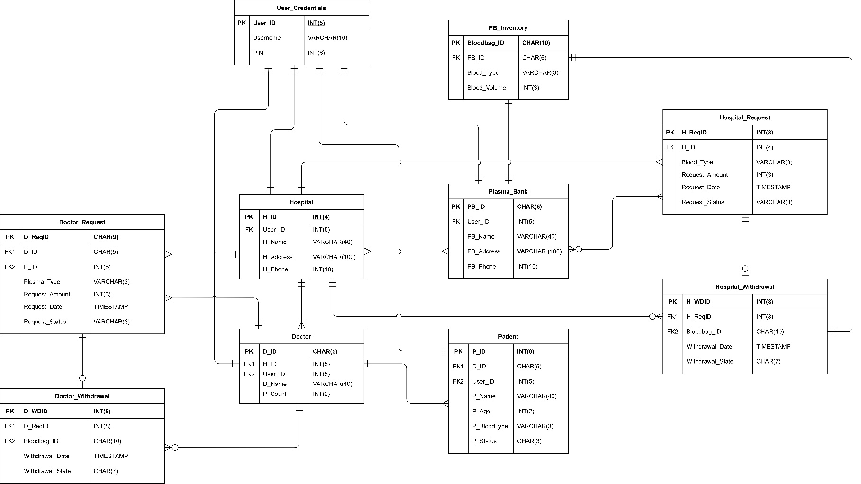

**Business Rules**

1. **Hospital**
   1. Each hospital can have many patients, but patient cannot be admitted to many hospitals at same time
   2. Each Hospital can have many doctors, but same doctors cannot work at different hospitals.
   3. Hospital can request plasma to many plasma banks but can withdraw from one bank for same request.
   4. Hospital can have many doctor requests.
2. **Doctor**
   1. Each doctor can have many patients, but patient cannot have many doctors.
   2. A doctor can work at one hospital only.
   3. Doctor can send many requests to hospital.
   4. Doctor can withdraw request from hospital.
3. **Patient**
   1. Patient can have only one doctor.
4. **Plasma Bank**
   1. Plasma banks can have many requests from many hospitals.

**User Level Security**

1. **Hospital**

Hospital will have admin level of security as shown in following diagram.

1. **Doctor**

Doctors can add/update/delete patient information, request and withdrawal of plasma to hospital as well.

1. **Patient**

Patient can only view patient related information.

1. **Plasma Bank**

Plasma Banks can add/update/delete plasma bank inventory of own inventory and can view/update hospital request and withdrawal.

**Tables**

1. User_Credentials

1. Hospital

1. Doctor

1. Patient

1. Plasma Bank

1. PB_inventory

1. Hospital_Request

1. Hospital_Withdrawl

1. Doctor_Request

1. Doctor_Withdrawal

SQL REPORT

**USE CASE 1: CITY WISE PATIENT COUNT AND ACT/REC PATIENT DATA**

ALL ACTIVE OR RECOVERED PATIENT CAN BE FOUND OUT USING SQL EASILY. IT WAS NOT POSSIBLE BEFORE AS DATABASE STORING WAS NOT CITY WISE.

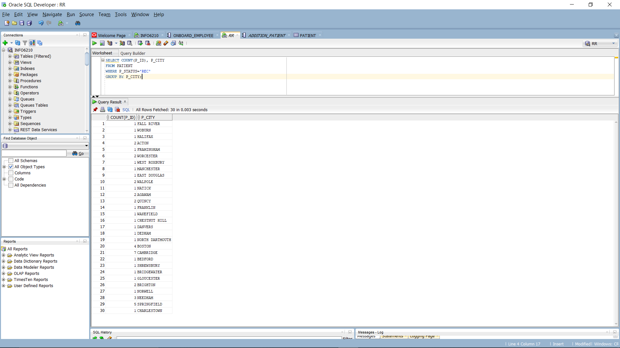

ACTIVE PATIENT ACCORDING TO CITY

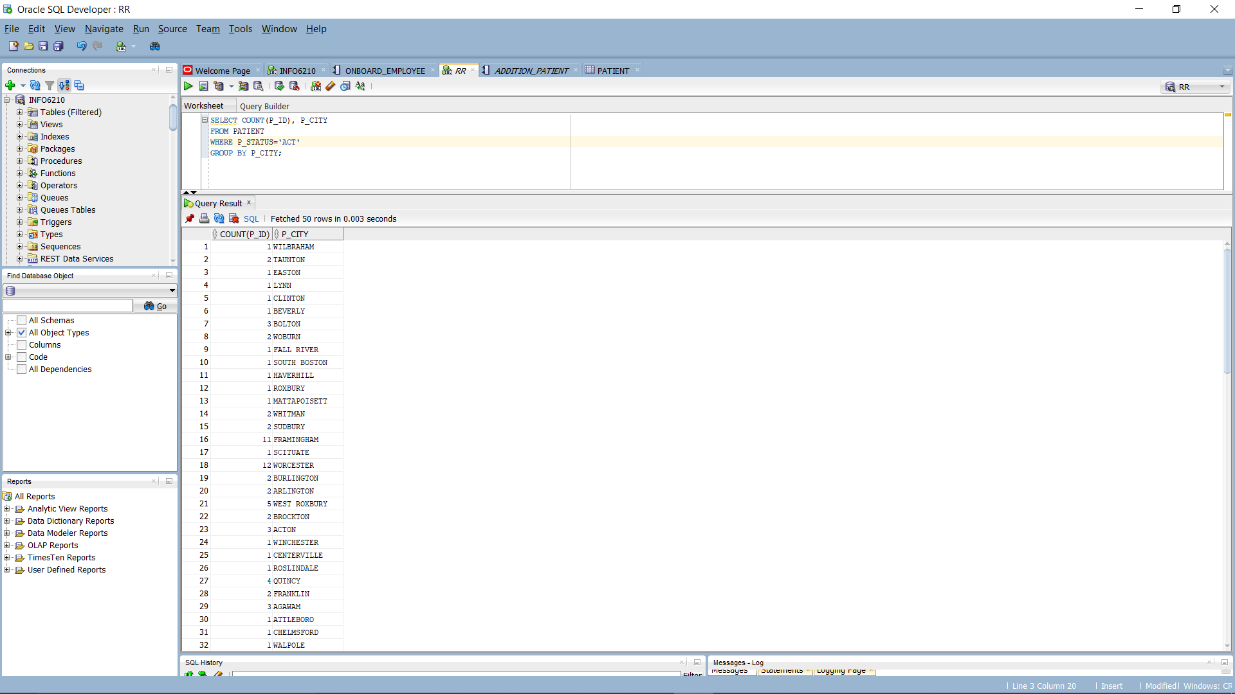

**USE CASE 2: NO OF PATIENT UNDER EACH DOCTOR**

COUNT OF PATIENT UNDER EACH DOCTOR CAN BE CALCULATED USING THIS DATABASE.

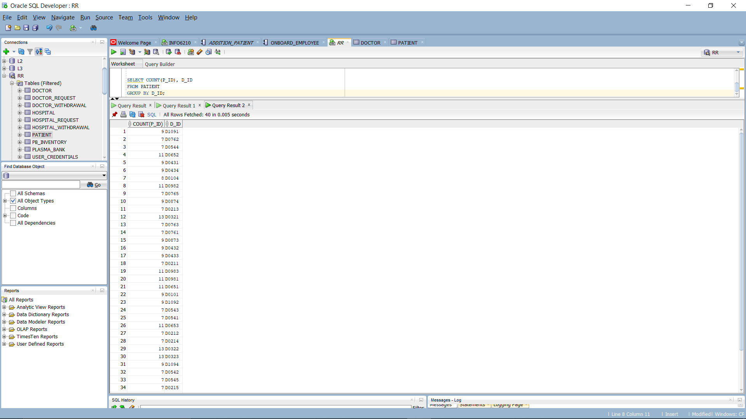

NO OF PATIENT ACCORDING TO BLOOD TYPE

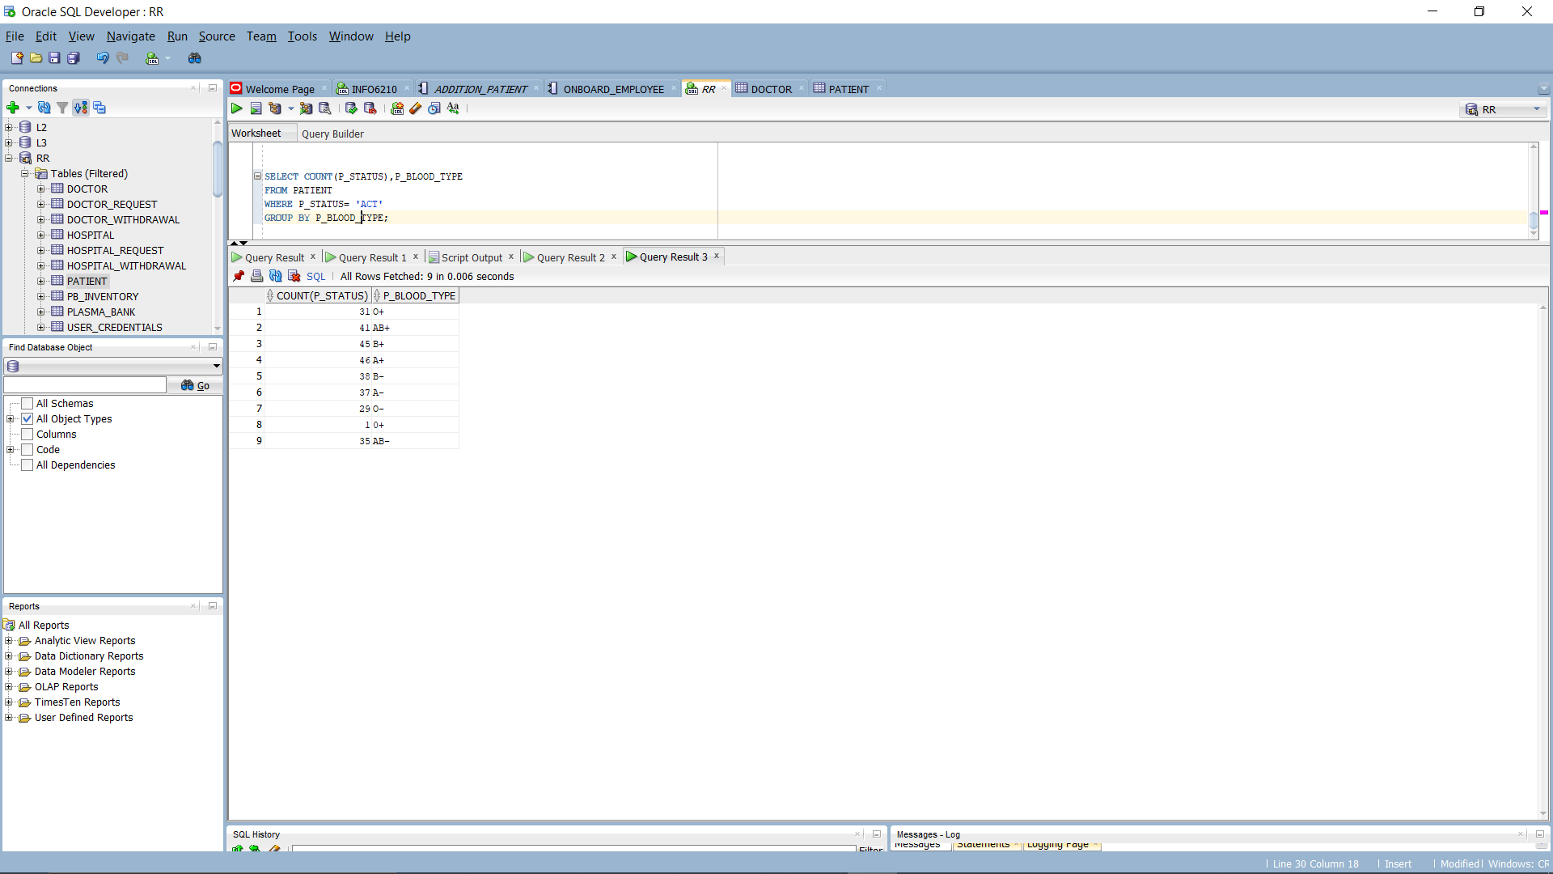

**USE CASE 3: BLOOD VOLUME AVAILABLE ACROSS ALL PLASMA BANK (INVENTORY)**

THIS HELPS US TO FIND BLOOD VOLUME REMAINING ACROSS CITY. SO THAT WE CAN COUNTINUE COVID TREATEMENT AHEAD. HOW MUCH DONATION IS REQUIRED?

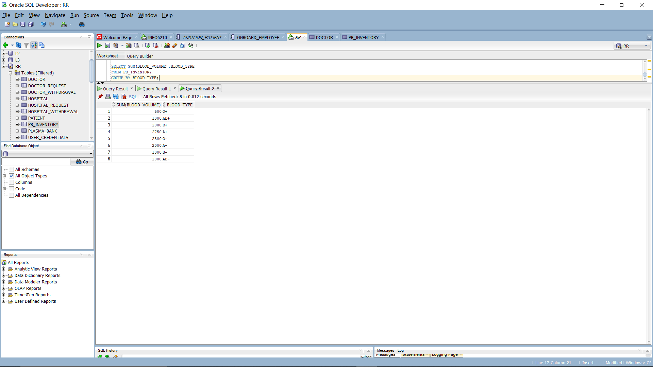

**USE CASE 4: MEDICAL HISTORY**

WITH THE HELP OF DATABASE, WE CAN ACHIEVE RESULTS REGARDING PATIENT RECOVERY. IT CAN BE SEEN THA PATIENT WITH SOME MEDICAL HISTORY TAKES TIME TO RECOVER WHILE PATIENT WITH NO MEDICAL HISTORY ARE RECOVERED IN MORE NUMBER. RECOVERY RATE OF PATIENT WITH NO OR LESS MEDICAL HISTORY IS HIGHER.

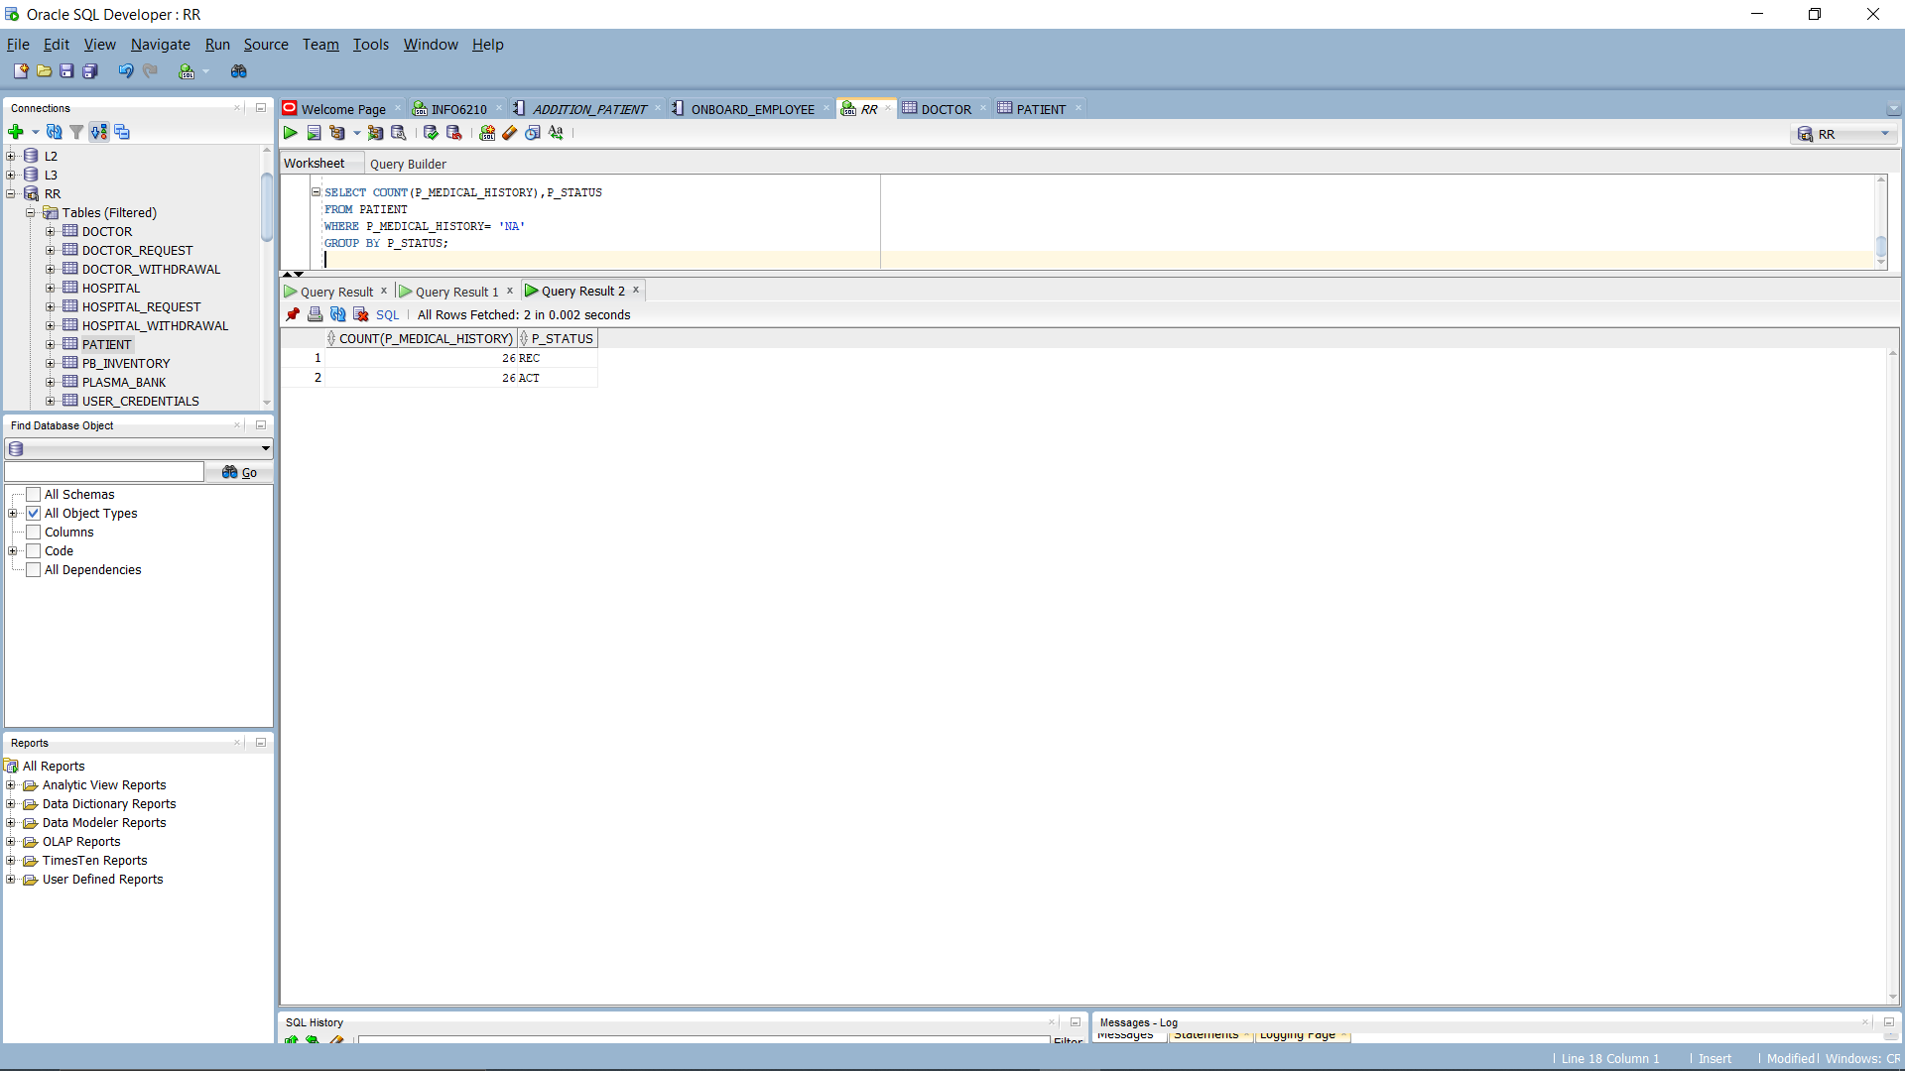

ACTIVE PATIENT ACCORDING TO MEDICAL HISTORY. THIS HELPS US TO FIND OUT WHICH PATIENT IS MORE SUSCEPTIBILE TOWARDS COVID-19 BECAUSE OF MEDICAL HISTORY.

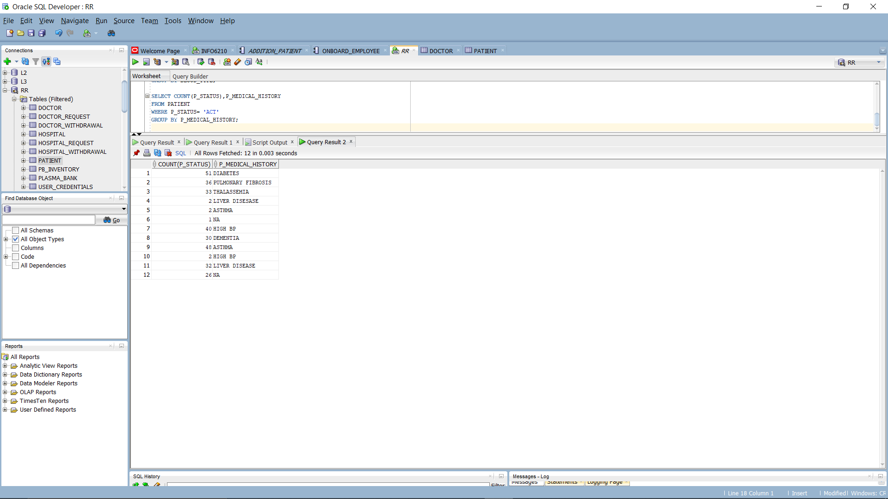

**USE CASE 5: WITHDRAWAL STATUS OF HOSPITAL REQUEST ACCORDING TO BLOOD TYPE**

**COMPLETE**

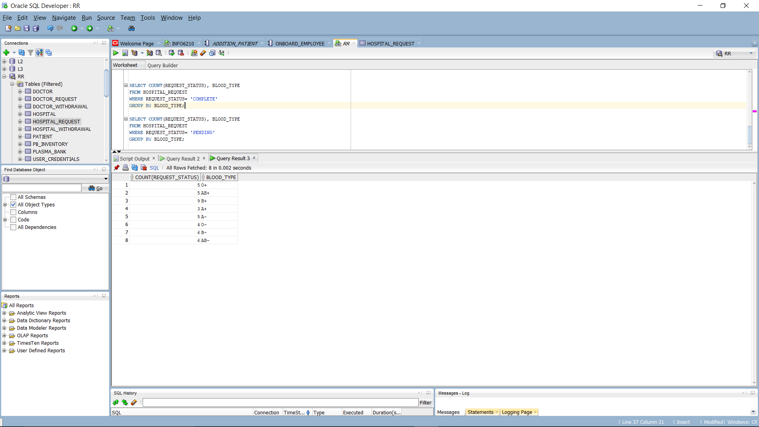

**PENDING REQUEST**

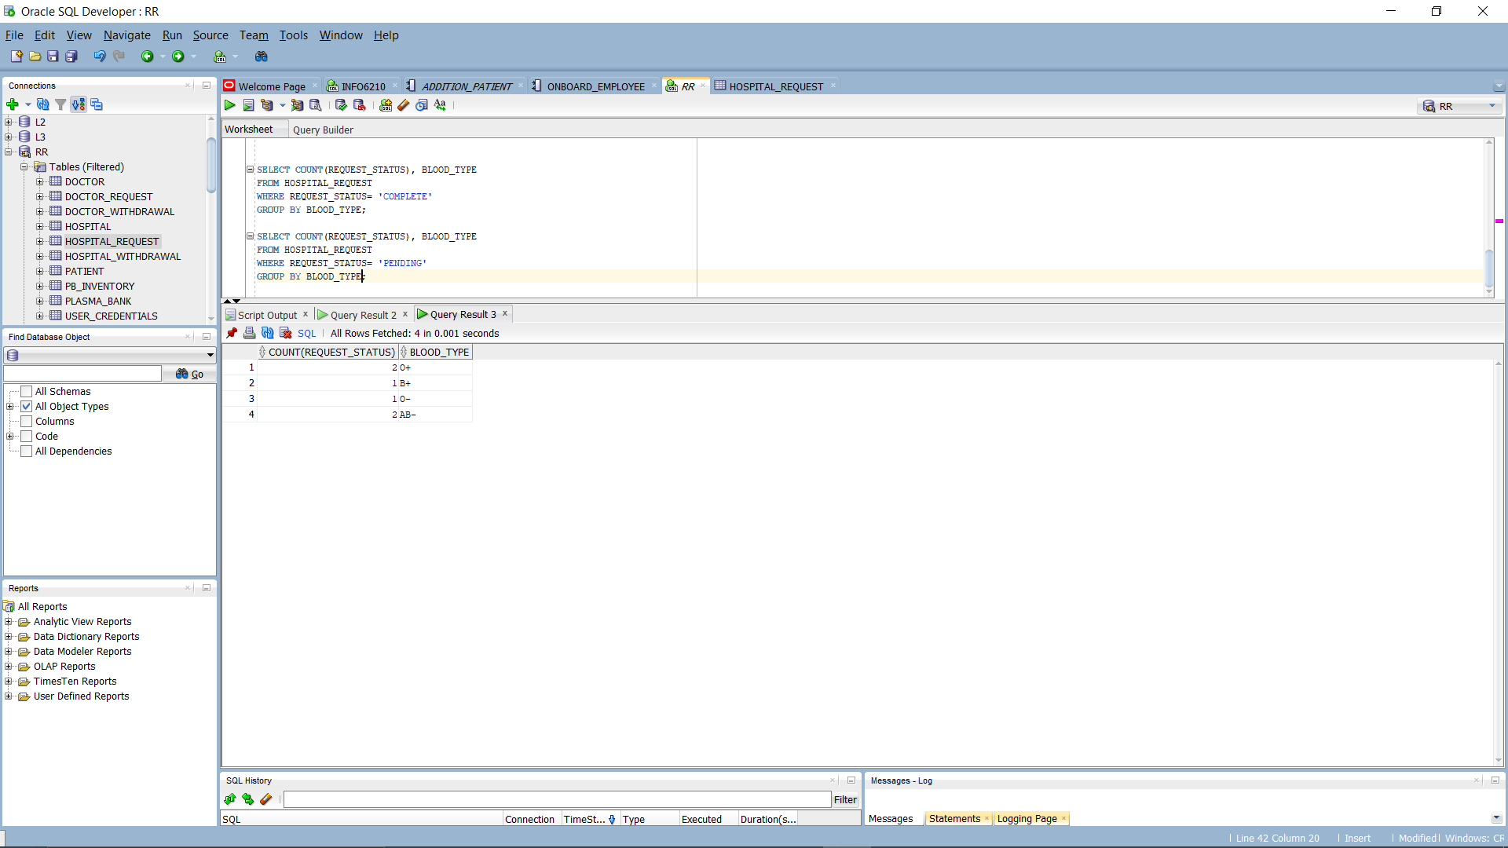

**CODE**